OS:
An operating system, or "OS," is software that communicates with the hardware and allows other programs to run. It is comprised of system software, or the fundamental files your computer needs to boot up and function. Every desktop computer, tablet, and smartphone includes an operating system that provides basic functionality for the device.
Common desktop operating systems include Windows, OS X, and Linux. While each OS is different, most provide a graphical user interface, or GUI, that includes a desktop and the ability to manage files and folders. They also allow you to install and run programs written for the operating system. Windows and Linux can be installed on standard PC hardware, while OS X is designed to run on Apple systems. Therefore, the hardware you choose affects what operating system(s) you can run.
Mobile devices, such as tablets and smartphones also include operating systems that provide a GUI and can run applications. Common mobile OSes include Android, iOS, and Windows Phone. These OSes are developed specifically for portable devices and therefore are designed around touchscreen input. While early mobile operating systems lacked many features found in desktop OSes, they now include advanced capabilities, such as the ability to run third-party apps and run multiple apps at once.
Since the operating system serves as a computer's fundamental user interface, it significantly affects how you interact with the device. Therefore, many users prefer to use a specific operating system. For example, one user may prefer to use a computer with OS X instead of a Windows-based PC. Another user may prefer an Android-based smartphone instead of an iPhone, which runs the iOS.
When software developers create applications, they must be write and compile them for a specific operating system. This is because each OS communicates with the hardware differently and has a specific application program interface, or API, that the programmer must use. While many popular programs are crossplatform, meaning they have been developed for multiple OSes, some are only available for a single operating system. Therefore, when choosing a computer, it is important to make sure the operating system supports the programs you want to run.

The operating system manages a computer's hardware resources, including:
- Input devices such as a keyboard and mouse
- Output devices such as display monitors, printers and scanners
- Network devices such as modems, routers and network connections
- Storage devices such as internal and external drives
The OS also provides services to facilitate the efficient execution and management of, and memory allocations for, any additional installed software application programs.
The OS consists of many components and features. Which features are defined as part of the OS vary with each OS. However, the three most easily defined components are:
- Kernel: This provides basic-level control over all of the computer hardware devices. Main roles include reading data from memory and writing data to memory, processing execution orders, determining how data is received and sent by devices such as the monitor, keyboard and mouse, and determining how to interpret data received from networks.
- User Interface: This component allows interaction with the user, which may occur through graphical icons and a desktop or through a command line.
- Application Programming Interfaces: This component allows application developers to write modular code.
Examples for OSs include Android, iOS, Mac OS X, Microsoft Windows and Linux.
Features of an Operating system are:
Hardware Management

One of the most important functions of an operating system is the management of all the computer's internal and external hardware. The operating system controls all connected devices, telling them how to operate and interact. The results of said operations and interactions are the basic performance of the computer. Some examples of the hardware that the operating system controls include the hard disk, optical drives, video cards and external port controllers, such as USB and Firewire.
Program Control
Operating systems also run programs, enabling them to operate and function as designed. Programs have to be designed to run with a particular operating system in order to function, as the operating system needs to display any interfaces and facilitate communications among the programs and your computer's connected hardware. Without the operating system to run it, programs can't perform their tasks.
Data Access
The operating system is also in charge of accessing, storing and retrieving data on the computer's hard drive. It also manages data stored temporarily in the computer's RAM memory. The data stored and retrieved can include document files, picture data, videos and music. While the hard drive itself reads and writes the data, the operating system tells it what to write and how to read it.
System Resource Management
The operating system manages a computer's resources, allocating them as needed. Which tasks the CPU processes in what order, which functions or programs are assigned processing power or memory first, and many other important resource allocation tasks are controlled by the operating system. Crucial operations are given priority based on presets inside the operating system that determine the importance of a process or program.

Network Communication
The operating system also facilitates network communication by enabling connected network devices to communicate with the computer and with any programs that require them. Network cards, such as Ethernet ports and wireless LAN cards, have the tools to connect with networks but need the operating system to direct their communication correctly so information can be exchanged. The operating system also interprets the information that comes in and determines which installed program can best display it for you.

- Provides User Interface.
- Hardware Adaptability.
- Memory Management.
- Task Management.
- Betworking Capability.
- Logical Access Security.
- File Management.

QUESTION:
What is difference between kernel and OS?
The kernel is a part of an operating system. The operating system is the software package that communicates directly to the hardware and our application. The kernel is the lowest level of the operating system. The kernel is the main part of the operating system and is responsible for translating the command into something that can be understood by the computer. The main functions of the kernel are:
- memory management
- network management
- device driver
- file management
- process management

History of Operating Systems
The First Generation (1940's to early 1950's)
When electronic computers where first introduced in the 1940's they were created without any operating systems. All programming was done in absolute machine language, often by wiring up plugboards to control the machine's basic functions. During this generation computers were generally used to solve simple math calculations, operating systems were not necessarily needed.

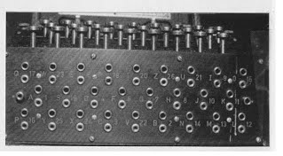

The Second Generation (1955-1965)
The first operating system was introduced in the early 1950's, it was called GMOS and was created by General Motors for IBM's machine the 701. Operating systems in the 1950's were called single-stream batch processing systems because the data was submitted in groups. These new machines were called mainframes, and they were used by professional operators in large computer rooms. Since there was such as high price tag on these machines, only government agencies or large corporations were able to afford them.

The Third Generation (1965-1980)
By the late 1960's operating systems designers were able to develop the system of multiprogramming in which a computer program will be able to perform multiple jobs at the same time.The introduction of multiprogramming was a major part in the development of operating systems because it allowed a CPU to be busy nearly 100 percent of the time that it was in operation. Another major development during the third generation was the phenomenal growth of minicomputers, starting with the DEC PDP-1 in 1961. The PDP-1 had only 4K of 18-bit words, but at $120,000 per machine (less than 5 percent of the price of a 7094), it sold like hotcakes. These microcomputers help create a whole new industry and the development of more PDP's. These PDP's helped lead to the creation of personal computers which are created in the fourth generation.

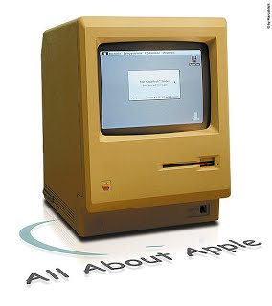

The Fourth Generation (1980-Present Day)
The fourth generation of operating systems saw the creation of personal computing. Although these computers were very similar to the minicomputers developed in the third generation, personal computers cost a very small fraction of what minicomputers cost. A personal computer was so affordable that it made it possible for a single individual could be able to own one for personal use while minicomputers where still at such a high price that only corporations could afford to have them. One of the major factors in the creation of personal computing was the birth of Microsoft and the Windows operating system. The windows Operating System was created in 1975 when Paul Allen and Bill Gates had a vision to take personal computing to the next level. They introduced the MS-DOS in 1981 although it was effective it created much difficulty for people who tried to understand its cryptic commands. Windows went on to become the largest operating system used in techonology today with releases of Windows 95, Windows 98, WIndows XP (Which is currently the most used operating system to this day), and their newest operating system Windows 7. Along with Microsoft, Apple is the other major operating system created in the 1980's. Steve Jobs, co founder of Apple, created the Apple Macintosh which was a huge success due to the fact that it was so user friendly. Windows development throughout the later years were influenced by the Macintosh and it created a strong competition between the two companies. Today all of our electronic devices run off of operating systems, from our computers and smartphones, to ATM machines and motor vehicles. And as technology advances, so do operating systems.

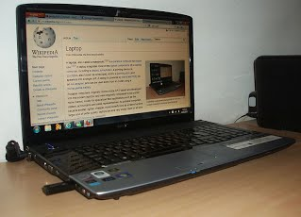

TYPES OF OPERATING SYSTEMS:
1. Batch Operating System –
This type of operating system do not interact with the computer directly. There is an operator which takes similar jobs having same requirement and group them into batches. It is the responsibility of operator to sort the jobs with similar needs.
Advantages of Batch Operating System:
- It is very difficult to guess or know the time required by any job to complete. Processors of the batch systems knows how long the job would be when it is in queue
- Multiple users can share the batch systems
- The idle time batch system is very less
- It is easy to manage large work repeatedly in batch systems
Disadvantages of Batch Operating System:
- The computer operators should be well known with batch systems
- Batch systems are hard to debug
- It is sometime costly
- The other jobs will have to wait for an unknown time if any job fails
Examples of Batch based Operating System: Payroll System, Bank Statements etc.

2. Time-Sharing Operating Systems –
Each task has given some time to execute, so that all the tasks work smoothly. Each user gets time of CPU as they use single system. These systems are also known as Multitasking Systems. The task can be from single user or from different users also. The time that each task gets to execute is called quantum. After this time interval is over OS switches over to next task.
Advantages of Time-Sharing OS:
- Each task gets an equal opportunity
- Less chances of duplication of software
- CPU idle time can be reduced
Disadvantages of Time-Sharing OS:
- Reliability problem
- One must have to take care of security and integrity of user programs and data
- Data communication problem
Examples of Time-Sharing OSs are: Multics, Unix etc.

3. Distributed Operating System –
These types of operating system is a recent advancement in the world of computer technology and are being widely accepted all-over the world and, that too, with a great pace. Various autonomous interconnected computers communicate each other using a shared communication network. Independent systems possess their own memory unit and CPU. These are referred as loosely coupled systems or distributed systems. These systems processors differ in sizes and functions. The major benefit of working with these types of operating system is that it is always possible that one user can access the files or software which are not actually present on his system but on some other system connected within this network i.e., remote access is enabled within the devices connected in that network.

Advantages of Distributed Operating System:
- Failure of one will not affect the other network communication, as all systems are independent from each other
- Electronic mail increases the data exchange speed
- Since resources are being shared, computation is highly fast and durable
- Load on host computer reduces
- These systems are easily scalable as many systems can be easily added to the network
- Delay in data processing reduces
Disadvantages of Distributed Operating System:
- Failure of the main network will stop the entire communication
- To establish distributed systems the language which are used are not well defined yet
- These types of systems are not readily available as they are very expensive. Not only that the underlying software is highly complex and not understood well yet
Examples of Distributed Operating System are- LOCUS etc.

4. Network Operating System –
These systems runs on a server and provides the capability to manage data, users, groups, security, applications, and other networking functions. These type of operating systems allows shared access of files, printers, security, applications, and other networking functions over a small private network. One more important aspect of Network Operating Systems is that all the users are well aware of the underlying configuration, of all other users within the network, their individual connections etc. and that’s why these computers are popularly known as tightly coupled systems.

Advantages of Network Operating System:
- Highly stable centralized servers
- Security concerns are handled through servers
- New technologies and hardware up-gradation are easily integrated to the system
- Server access are possible remotely from different locations and types of systems
Disadvantages of Network Operating System:
- Servers are costly
- User has to depend on central location for most operations
- Maintenance and updates are required regularly
Examples of Network Operating System are: Microsoft Windows Server 2003, Microsoft Windows Server 2008, UNIX, Linux, Mac OS X, Novell NetWare, and BSD etc.

5. Real-Time Operating System –
These types of OSs serves the real-time systems. The time interval required to process and respond to inputs is very small. This time interval is called response time.

Real-time systems are used when there are time requirements are very strict like missile systems, air traffic control systems, robots etc.
Two types of Real-Time Operating System which are as follows:
- Hard Real-Time Systems:
These OSs are meant for the applications where time constraints are very strict and even the shortest possible delay is not acceptable. These systems are built for saving life like automatic parachutes or air bags which are required to be readily available in case of any accident. Virtual memory is almost never found in these systems.
- Soft Real-Time Systems:
These OSs are for applications where for time-constraint is less strict.
Advantages of RTOS:
- Maximum Consumption: Maximum utilization of devices and system,thus more output from all the resources
- Task Shifting: Time assigned for shifting tasks in these systems are very less. For example in older systems it takes about 10 micro seconds in shifting one task to another and in latest systems it takes 3 micro seconds.
- Focus on Application: Focus on running applications and less importance to applications which are in queue.
- Real time operating system in embedded system: Since size of programs are small, RTOS can also be used in embedded systems like in transport and others.
- Error Free: These types of systems are error free.
- Memory Allocation: Memory allocation is best managed in these type of systems.
Disadvantages of RTOS:
- Limited Tasks: Very few task run at the same time and their concentration is very less on few applications to avoid errors.
- Use heavy system resources: Sometimes the system resources are not so good and they are expensive as well.
- Complex Algorithms: The algorithms are very complex and difficult for the designer to write on.
- Device driver and interrupt signals: It needs specific device drivers and interrupt signals to response earliest to interrupts.
- Thread Priority: It is not good to set thread priority as these systems are very less pron to switching tasks.
Examples of Real-Time Operating Systems are: Scientific experiments, medical imaging systems, industrial control systems, weapon systems, robots, air traffic control systems, etc.
Question:
Provide 3 examples of each of above types of OS except for networked OS
ARCHITECTURE OF OPERATING SYSTEMS:
OS ARCHITECTURE DEFINITION:
For an operating system to be a useful and convenient interface between the user and the hardware, it must provide certain basic services, such as the ability to read and write files, allocate and manage memory, make access control decisions, and so forth. These services are provided by a number of routines that collectively make up the operating system kernel. Applications invoke these routines through the use of specific system calls. Because the kernel routines exist for the purposes of supplying specific services, the operating system has an underlying structure defined by these services. This underlying structure and its design are called the system architecture. The terms system architecture and system structure are used somewhat synonymously.
Software engineers design and implement the system architecture of an operating system so that its parts work well together. System administrators, system programmers, applications programmers, and users refer to the system architecture to provide a conceptual understanding of the parts of the operating system and the relationships among them.
Sound system architecture is an important aspect of ensuring that the operating system is secure.

Simple Structure

There are many operating systems that have a rather simple structure. These started as small systems and rapidly expanded much further than their scope. A common example of this is MS-DOS. It was designed simply for a niche amount for people. There was no indication that it would become so popular.

An image to illustrate the structure of MS-DOS is as follows:
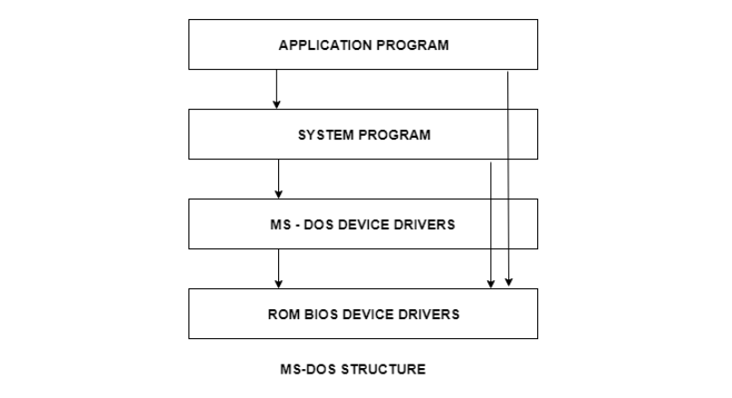
It is better that operating systems have a modular structure, unlike MS-DOS. That would lead to greater control over the computer system and its various applications. The modular structure would also allow the programmers to hide information as required and implement internal routines as they see fit without changing the outer specifications.

Layered Structure
One way to achieve modularity in the operating system is the layered approach. In this, the bottom layer is the hardware and the topmost layer is the user interface.
An image demonstrating the layered approach is as follows:
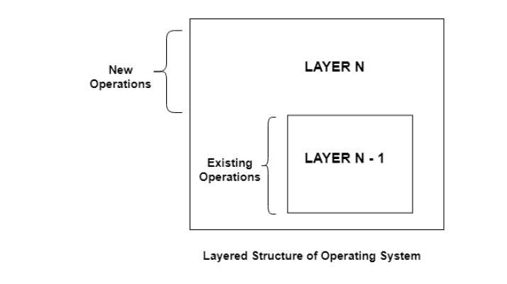

The core software components of an operating system are collectively known as the kernel. The kernel has unrestricted access to all of the resources on the system. In early monolithic systems, each component of the operating system was contained within the kernel, could communicate directly with any other component, and had unrestricted system access. While this made the operating system very efficient, it also meant that errors were more difficult to isolate, and there was a high risk of damage due to erroneous or malicious code.
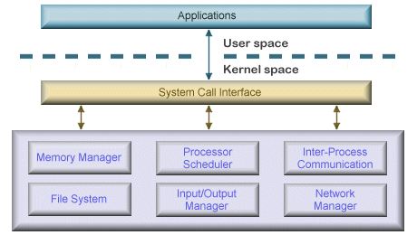

As operating systems became larger and more complex, this approach was largely abandoned in favour of a modular approach which grouped components with similar functionality into layers to help operating system designers to manage the complexity of the system. In this kind of architecture, each layer communicates only with the layers immediately above and below it, and lower-level layers provide services to higher-level ones using an interface that hides their implementation.
The modularity of layered operating systems allows the implementation of each layer to be modified without requiring any modification to adjacent layers. Although this modular approach imposes structure and consistency on the operating system, simplifying debugging and modification, a service request from a user process may pass through many layers of system software before it is serviced and performance compares unfavourably to that of a monolithic kernel. Also, because all layers still have unrestricted access to the system, the kernel is still susceptible to errant or malicious code. Many of today’s operating systems, including Microsoft Windows and Linux, implement some level of layering.
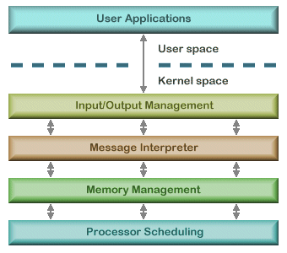

A microkernel architecture includes only a very small number of services within the kernel in an attempt to keep it small and scalable. The services typically include low-level memory management, inter-process communication and basic process synchronisation to enable processes to cooperate. In microkernel designs, most operating system components, such as process management and device management, execute outside the kernel with a lower level of system access.
Microkernels are highly modular, making them extensible, portable and scalable. Operating system components outside the kernel can fail without causing the operating system to fall over. Once again, the downside is an increased level of inter-module communication which can degrade system performance.
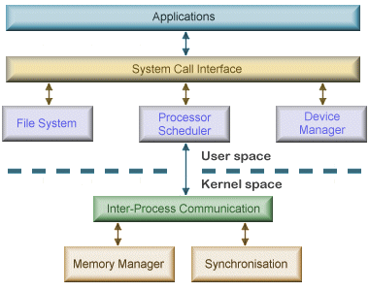

CPU AND RESOURCES MANAGEMENT:

NB:
DETAILED NOTES IN OS ARCHITECTURE PDF

